AARP holding area location candidates

1) Ignazio’s Pizza
4 Water Street
Has chairs and tables and everything we need
Would include food and soft drinks, but it isn’t “Film biz entrees”-type food. More like subs and pizza.
SECONDS FROM CAMERA
WOULD NOT NEED A MOHO

$7000 for 5AM to 5PM

2) Plymouth Church
57 Orange Street
Has chairs and tables and everything we need
NO AC but plenty of fans
8-10 Minute walk to camera (downhill to camera uphill from)
WOULD STILL NEED A MOHO NEAR CAMERA

(tiresome parking. Not that we’d need any except a drop off, but…)

$2000 for 5AM to 5PM

3) 14-18 Fulton Corp
AT Old Fulton Street and Everit
Is just an open area for tents and chairs and VID VILLAGE
No chairs or tables, NO BATHROOM, NO ELECTRICITY
Would need to allow a center “aisle” for plumbers
Right next to camera
WOULD STILL NEED A MOHO NEAR CAMERA

$4000 (wanted $5K)

4) The Dumbo Loft
155 Water Street
Has chairs and tables and everything we need
8 minute walk to camera
WOUD STILL NEED A MOHO NEAR CAMERA

$3000

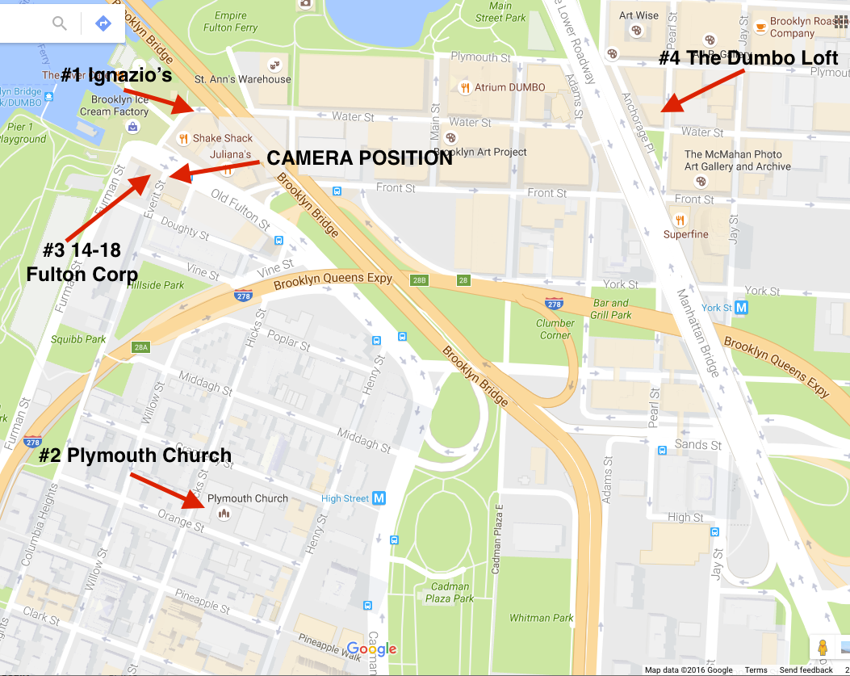

Not available:

- St Ann’s Warehouse Theater. Normally cooperative, but they have a “tenant” in that space till September. Seconds from Camera.

- Brooklyn Eagle Warehouse. Have nothing.

- Watchtower. Doesn’t do it. Ever. Though immaterial, they were VERY nice to me.

- Grimaldi’s. “The landlord doesn’t allow us to do it anymore.”

Waiting to hear:

TWO TREES REAL ESTATE
45 Main St (At Water Street)
#601
Brooklyn

They are a big deal. Own a lot of real estate in the area and I met them and have submitted a letter of intent. They are $$$ and it would be a RAW space where we’d have to load in, etc.

